## 

Team 8

Teamwork - Vending Machine 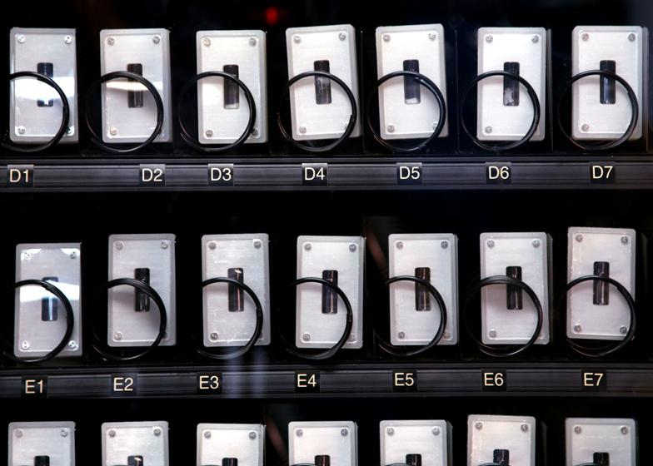

KATLEGO MOSHUGI

MAMELLO MOTAUNG

KARABO MOTSEPE

MDUDUZI MSIZA

KAIZER MTHIMKHULU

PHUMUDZO MUVHANGO

PORTIA MVUNDLELA

THABISO MZIZI

N NAIDOO

HEINO NEL

**Table of Contents**

|  |  |
| --- | --- |
| **Content** | **Page** |
| **Problem Statement** | **1** |
| **Diagrams** | **2** |
| **Planning Document** | **3** |
| **End-user Documentation** | **3** |

**Problem Statement**

1st Problem Statement

A vending machine that is automated to provide soft drinks for the consumers. The vending machine accepts Quarters(Q) which is equivalent to 25c and Nickels(N) which is equivalent to 5c. Look at the Finite State Machine (FSM) of the vending machine given in figure 3.5 on page 101, then document the diagrams, planning documents and end user document and write a CLIPS source code for the vending machine.

2nd Problem Statement

A vending machine that is automated to provide soft drinks and snacks for the consumers. The machine accepts R5, R2, R1, 50c, 20c and 10c as payment. Every drink and snacks have a different price and the machine returns change, the vending machine has a stock of two types of drinks and two types of snacks. The drinks are Cola which is R8.50 and Orange for R10.00, then the snacks are Sweets for R12.50 and Chocolate for R15.00. Write a CLIPS source code that will calculate the change, document diagrams, planning documents and end user documentation for the vending machine. (by: Kaizer Mthimkhulu-28320298)

# 

# Diagrams

# Finite State Diagram For Vending Machine

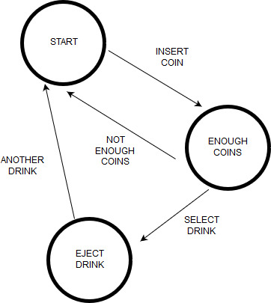

(by : Phumudzo Muvhango)

**Planning documents**

Our planning for this vending machine github assignment consists of no meetings, mostly communication through whatsapp, google docs and the efundi forum. The gitHub repository was created by Heino Nell and then requested usernames to add us contributors. All documentation and planning was done on google docs created by karabo Motsepe and whatsapp was used to coordinate everything. The final documentation was compiled and uploaded to the github repository on the 15th of april 2018.

(by : Karabo Motsepe)

**End user documentation**

Vending machines are electronic machines that disperse beverages and snack items, they are indispensable resources that save time and make it possible for the user to purchase snacks when the stores are closed. Vending machines take cash from the slot coin, and allow a user to select a product of choice by pressing the button, and typing letters and/or numbers that correspond with that snack on the keyboard in front of the vending machine. The snack will fall on the retrieval unit and returns the change on the change dispenser near the button. Sometimes the machine rejects if the customer inserted insufficient coins,then the coins will fall onto the change dispenser and allow the user to feed the machine until they have paid necessary amount(shown in digital display).

(by: Portia Mvundlela)